Information on CAD Files
Joystick main body V2.0.stl
– 3D CAD file produced using Autodesk Fusion 360 2026
Joystick main body v2.0_0.6n_0.25mm_PLA_MK4S_1h0m.bgcode
– G-code file produced using PrusaSlicer 2.9.5
Joystick cap.stl
– Legacy STL file by Group Trentino. The component was re-used as the current Joystick body designed to be reverse compatible with it
Side holder.stl
– Legacy STL file by Group Trentino. The component was re-used

3D Printing Protocols & Slice Metrics
- Hardware : Prusa MK4S 3D Printer
- Nozzle : 0.6mm
- Slicing Engine: PrusaSlicer 2.9.5.
- Slicing Profile: 0.25mm Speed Layer Height.
- Filament Profile: Extrudr GreenTEC Pro (PLA)

Production Metrics:
  - Total Filament Consumed: 45.66 grams
  - Total Printing Execution Time: 1 Hour
  - Calculated Net Material Cost: €2.57
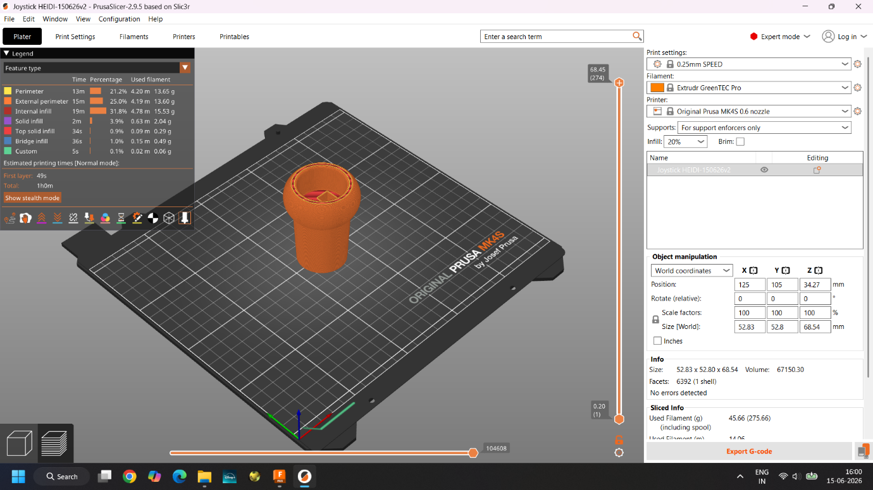
Figure 1 : Screenshot from PrusaSlicer Interface (Sliced model)

